Experience the Happiness of an Italian Feast
with Grana Padano PDO & Prosciutto di Parma PDO
for the first time in Restaurant & Bar - Hong Kong 2017

(Hong Kong, August 2017) Italian food products are always great nutritious choices for fine dining in Hong Kong, confirmed by the popularity of Parma Ham and Grana Padano cheese.

2017 marks the first year of a 3 year collaboration for the CONSORZIO TUTELA GRANA PADANO & CONSORZIO DEL PROSCIUTTO DI PARMA in Asia. For Hong Kong, it starts officially at Restaurant and Bar 2017 at Hong Kong Convention & Exhibition Centre from 5 to 7 September, with an 18-sqm booth: GB 18 in Hall 5FG. During three days of the event for trade professionals and media, you will be able to visit the booth, familiarise yourself with the taste of Grana Padano cheese and Parma Ham, and also meet with their respective representatives.

Both products are Protected Designation of Origin, a recognition for certified and high-quality products.
PDO (short for Protected Designation of Origin) is a European Community certification system designed to protect the names and traditions of high-quality European foods made according to traditional methods in a defined geographic region.

Prosciutto di Parma®, a world famous-ham cured in the gently rolling countryside near Parma, Italy

Since Roman times, the unique conditions of the Parma region have made it possible to produce hams of the finest quality. Just four natural ingredients are used to make Prosciutto di Parma PDO: Italian pigs, salt, air and time. Every Parma Ham is produced without the use of any chemicals -- it is 100% NATURAL: "No additives, No colouring, No preservatives such as nitrites and nitrates"!

High Quality - from Meat to Production

The pigs used in the production of Parma Ham must be born and raised on approved farms located in one of the specified then northern and central Italian regions.

Only three breeds of pigs may be used for Parma Ham: Large White, Landrace and Duroc. Their diet is a specially regulated blends of grains, cereals and whey from local cheese production, thereby ensuring a heavy pig enjoying a moderate daily growth rate and an excellent state of health. The hams are made from the rear legs of pigs that must be at least nine months old and weigh a minimum of 140 kg at the time of slaughter.

The curing is controlled carefully so that the ham absorbs only enough salt to preserve it. By the end, a trimmed ham will have lost more than a quarter of its weight through moisture loss, thus helping to concentrate the flavour. At this stage, the meat becomes tender and the distinctive aroma and flavour of Parma Ham emerge.

Every leg of Prosciutto di Parma PDO is aged for at least 400 days and up to a maximum of 30 months. On average, each ham contains only a 3.5% level of salt. In fact, the product's sweetness and nuttiness are the signature flavours of its production.

No Crown = No Parma Ham

At the end of the ageing process, the hams are ready to qualify for the Parma Crown - the official stamp of certification. Qualified inspectors test the hams with a horse bone needle and issue a quality judgement based on the taste, colour and aroma; only hams with the high standard of the consortia are branded with the Parma Crown and become Parma Ham. The Ducal crown is your guarantee of quality and authenticity.

Grand Padano, the best-selling PDO cheese in the world and one of the most loved in Italy

It was around the year 1135 that the Benedictine monks of the flat, fertile Pianura Padana (Po River Valley), in Northern Italy, created an original masterpiece: an absolutely unique recipe for transforming surplus milk into a fine, delicious cheese, with an intense flavour that has stood the test of time.

Grana Padano acquires its name due to its granular texture (“grana” means “grain” in Italian) and “Padano” from its production area, Pianura Padana.

Strict controls, every step of the production

In accordance with the original recipe, which has remained unchanged for almost a thousand years, Grana Padano PDO is made from fresh, raw, partially skimmed cows’ milk collected within the clearly defined Production Area specified in the Production Specifications.

At 9 months of ageing, each wheel undergoes strict tests for appearance, aroma and texture, before receiving the characteristic fire branding. An independent certification body and the Consortium’s technicians carry out this important step.

Grana Padano PDO contains a high concentration of milk nutrients: 60g of Grana Padano PDO contain the same nutritional value as one litre of milk, while the proteins are also very rich in essential amino acids.

Three Vintages, Three Delicacies

Aged between 9 and 16 months, Grana Padano PDO is softer and less grainy than the more mature versions. Pale yellow in colour, its taste is mild, milky and delicate.

With a soft straw-yellow colour, Grana Padano “over 16 months” has a grainier consistency and crumbles when cut. The sweetness in its flavour is less noticeable and it has a stronger, though never overpowering, tangy taste.

Grand Padano "Riserva" is aged over 20 months and is fire-branded with the Riserva mark only after passing an additional quality test carried out by the Consortium's technicians. Grana Padano Riserva is distinctly grainy in texture, and has a consistent deep straw-yellow colour. It acquires a richer, fuller flavour, but without becoming too aggressive

The marks of origin on Grana Padano

Every producer of Grana Padano must strictly observe the regulations provided by the long-standing traditional recipe, which has been approved by the European Union. These regulations establish the cows' diet, define the area of production and local milk supply, and meticulously regulate every stage of the production. In 1996, Grana Padano became one of the first dairy products to be awarded the Designation of Protected Origin status.

Several unique markings are found on each wheel of Grana Padano that guarantee its authenticity. A four-leaf clover stamp confirms the origin and includes the Province's code and the producer's registration number. The pin-dot lozenges stamped on the rind are accompanied by the words <<Grana>> and <<Padano>>. These marks ensure that it is genuine Grana Padano -- especially when the cheese has been cut into portions.

Come to Restaurant & Bar and Experience the Wonderful Products

Please come to Restaurant & Bar HK 2017 to learn more about these great products first-hand. You can taste Prosciutto di Parma PDO aged for 16 and 24 months respectively, as well as the Grana Padano aged 15 and 24 months. For the occasion, both Consorzia will be sending delegations from whom you can gain a fuller understanding and appreciation of the products. The representatives will be available for interviews, including Mr Paolo TRAMELLI, Marketing Manager of Consorzio del Prosciutto di Parma, and, Mr Nicola Cesare BALDRIGHI, President of Consorzio Tutela Grana Padano.

Let more and more local people enjoy the premium Italian PDO products!

For further information, please contact:

Sopexa Hong Kong Limited  Ms. Julia Iaconelli – Senior Project Manager  Tel: 2866 7163  E: Julia.iaconelli@sopexa.com | Sategy Communications Limited  Ms. Gladys Hau – PR Representative  Tel: 2881 5256  E : sategy@sategy.com.hk

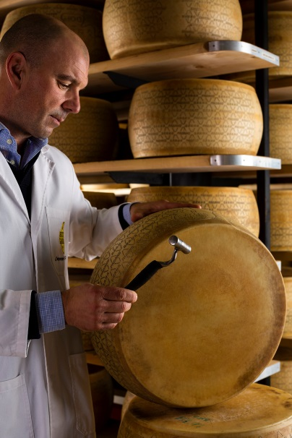 | 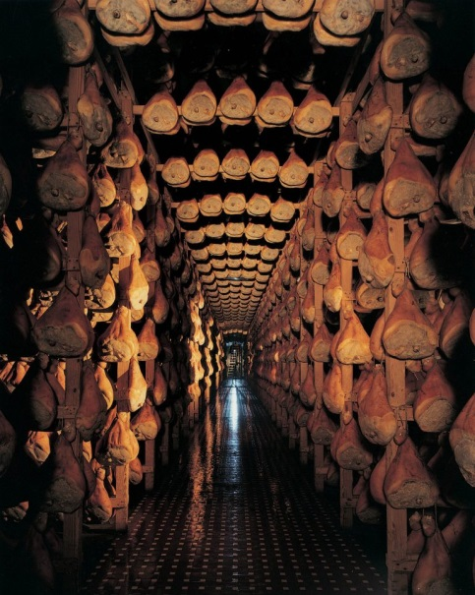
[…] each wheel undergoes strict tests for appearance, aroma and texture, before receiving the characteristic fire branding. | Every leg of Prosciutto di Parma PDO is aged for at least 400 days and up to a maximum of 30 months.
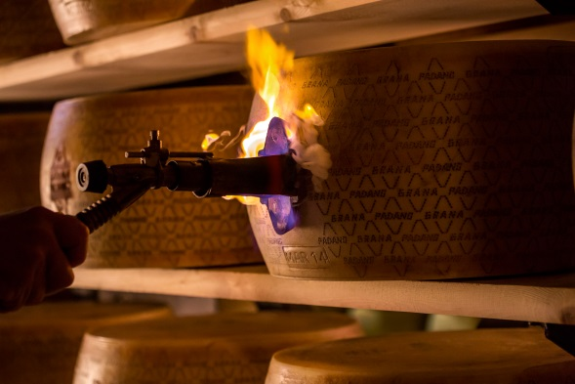 | 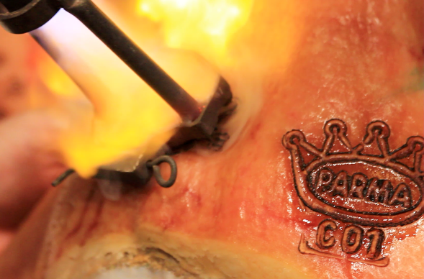
A four-leaf clover stamp confirms the origin and includes the Province's code and the producer's registration number. The pin-dot lozenges stamped on the rind are accompanied by the words <<Grana>> and <<Padano>>. | At the end of the ageing process, the hams are ready to qualify for the Parma Crown - the official stamp of certification. […]only hams with the high standard of the consortia are branded with the Parma Crown and become Parma Ham.
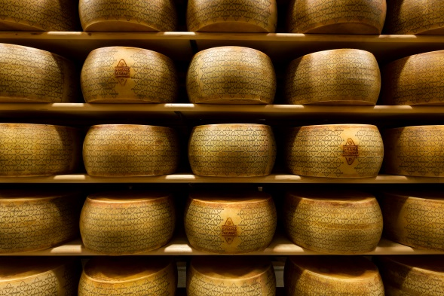 | 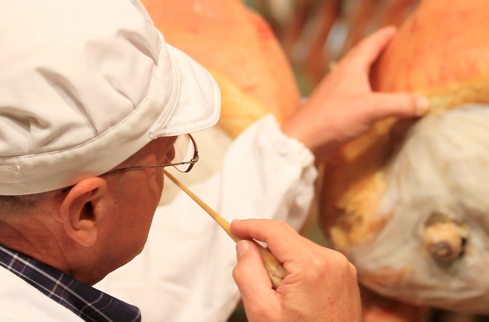
In 1996 Grana Padano became one of the first dairy products to be awarded the Designation of Protected Origin status. | Qualified inspectors test the hams with a horse bone needle and issue a quality judgement based on the taste, colour and aroma;

