Launching of EU Campaign of Grana Padano & Parma Ham
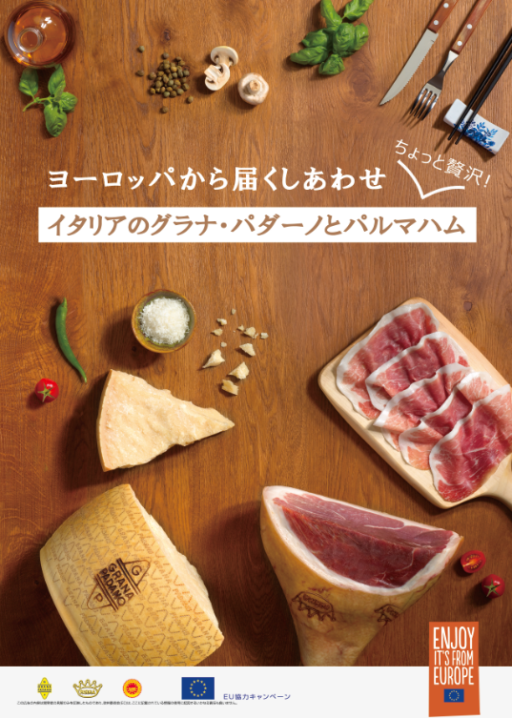
August 2017
The Consorzio Tutela Grana Padano and Consorzio del Prosciutto di Parma will develop triennial European Communication Program <Euperte> for the promotion of Grana Padano & Prosciutto di Parma in Japan. The communication objectives are strengthening knowledge in order to make the PDO products specificities more understandable and building the awareness and image in order to create a real preference between professional or consumers and the European PDO products. The commercial objectives are to create an enabling environment to allow business relations to flourish on a rapidly growing market and to support and energize sales growth through strengthening existing sales channels and developing new channels.
You will find the main actions planned between September 2017 to March 2018. The details of each action will be informed to you later. Thank you very much for your interest and concern on this projects.
September 2017ーMarch 2018
【Primary Target: Professionals, Influencers】
-Training seminars for Trade,
-Training for demonstrators,
-Seminars at Cooking Colleges
-Italian Restaurant Week
-Event-Stand at Supermarket Trade Show 2018
-Event-Stand at Foodex 2018
-POS promotion: Tasting Demonstrations
-Advertising: Print (journal and magazine)
【Secondary target: consumers】
-Web&SNS Campaign
-Reportage by Brand Ambassadeur for TV
-Event: Cooking classes for food creators Club,
VISUEL DEVELOPPED FOR NEW CAMPAIGN
Meal is an important time of the day, and even more, it’s an opportunity to share and discover extraordinary flavors. If you want to enjoy the moment and tasting guaranteed flavors, just choose European products with PDO. The essential ingredient for any Italian Is happiness and enjoying good food with friends…The authentic experience can guarantee your happiness! HAPPINESS FROM EUROPE WITH GRANA PADANO PDO&PROSCIUTTO DI PARMA PDO, THE MEAL BECOMES AN ITALIAN FEAST.

About GRANA PADANO
Grana Padano is the best-selling PDO cheese in the world and one of the most loved in Italy.
It was around the year 1135 that the Benedictine monks of the flat, fertile valley of the River Po in northern Italy created an original masterpiece: an absolutely unique recipe for transforming surplus milk into a fine, delicious cheese, with an intense Flavour that stood the test of time.
Due to its “granular” structure, it was natural to call this cheese “Grana”. This is how Grana Padano, with its unmistakable flavor, was born and “Padano” from the Production Area (Padana Valley in northern Italy). At 9 months of ageing, each wheel undergoes strict tests for appearance, aroma and texture, before receiving the characteristic fire-branding and become Grana Padano PDO.

About PARMA HAM
Prosciutto di Parma® is a world-famous ham cured in the gently rolling countryside near Parma, Italy.
Making a Parma Ham is a long and painstaking process; all producers of Prosciutto di Parma share one goal: To cure a leg of pork with pure sea salt in order to keep the meat as sweet-tasting and as supple as possible. The hams are made from the rear haunches of the pig; The curing is controlled carefully so that the ham absorbs only enough salt to preserve it. By the end, a trimmed ham will have lost more than a quarter of its weight through moisture loss, helping to concentrate the flavour. The meat becomes tender and the distinctive aroma and flavour of Parma Ham emerge.

Contact：pr_jp@sopexa.com SOPEXA JAPAN
〒150-0013 3F 3-12-8 Ebisu Shibuya-ku /Tel:03-5789-1070

